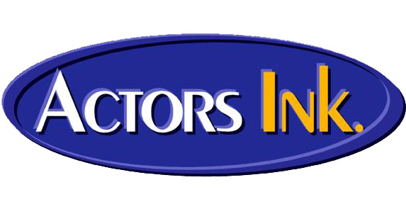

SHORT FILM PRODUCER INFO

FILM NAME:

PRODUCER DETAILS

Producer Name:
Phone # 1:
2:
Email Address:

2nd Contact
Name:
Role:
Phone # 1:
2:
Email Address:

AUDITION & SHOOT DETAILS

We have 5 studios at Actors Ink which can be used Monday to Friday between 10am – 3pm free of charge for audition purposes…… It is preferred auditions are conducted at Actors Ink.

Audition Location:

Audition Dates:

Audition Times:

Film Shoot Dates:

